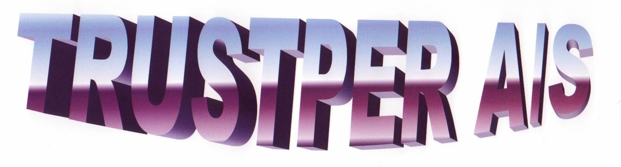

BALLAST TANK MAINTENANCE CONCEPT THINKING “GREEN”

P r o v i d e s T r e m e n d o u s S a v i n g P o t e n t i a l

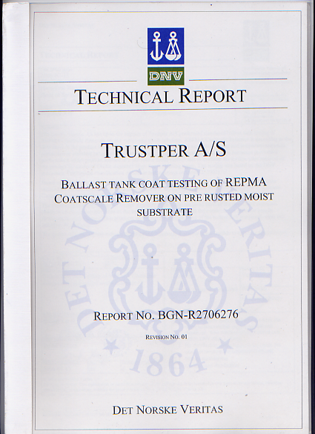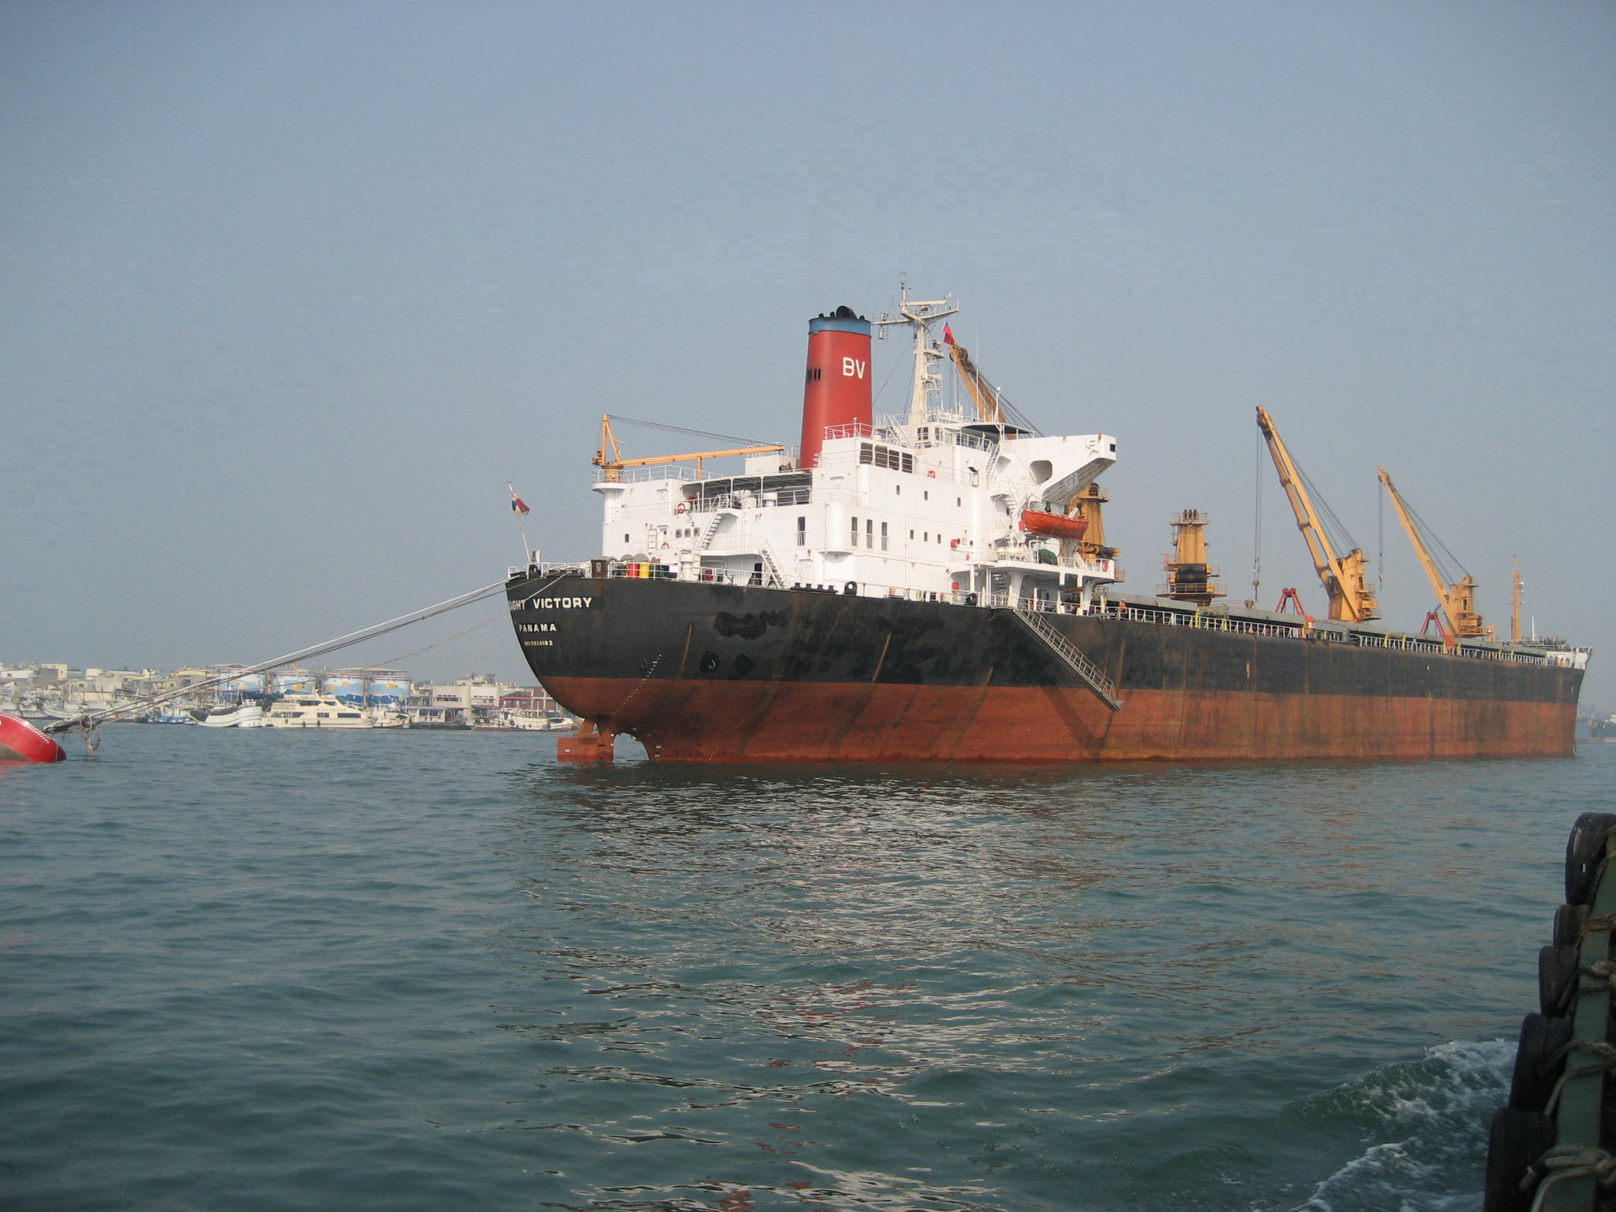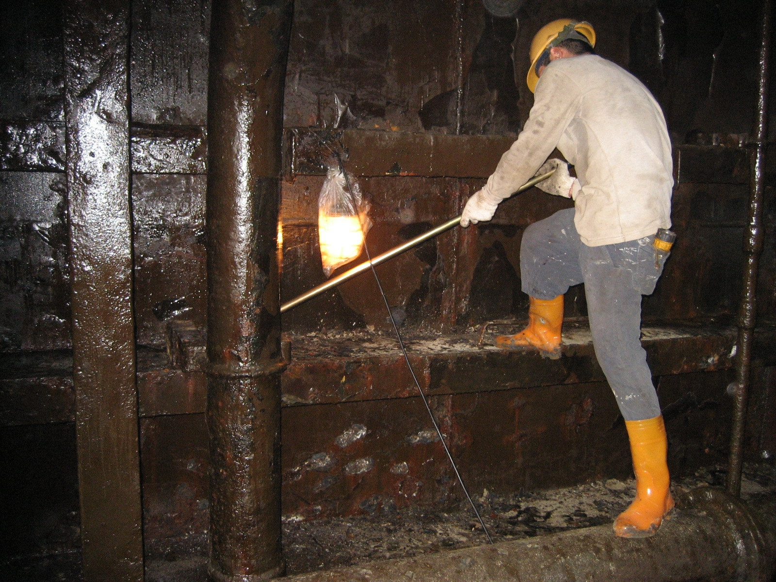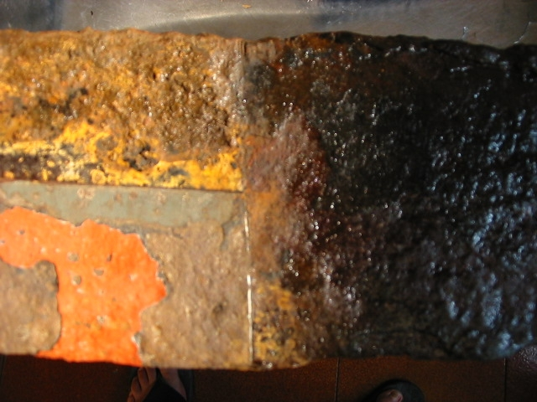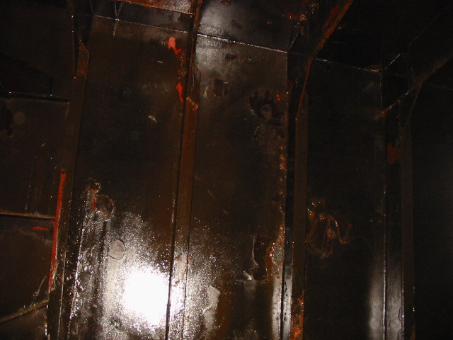

The “New Work Method” designated to fight onboard Corrosion in a new manner!

As Ship Owner or Ship Management Company you have most certainly been encountering that one vessel or more in the fleet are exposed to corrosion challenges from time to time.
We all know that serious action has to be taken in one way or the other unless the only “option” left is the exchange of steel during the vessels dry docking facing heavy financial loss including the off hire, which should be avoided. One option is actual highly cost efficient!
By applying your vessels or off-shore rig’s own crew during the ordinary operational conditions, Owners should have good reasons to expect that satisfactory end results now could be within reach in order to achieve sound steel surfaces after treatment having carried out the pre-cleaning on severe corroded mild steel-plates & internals within ballast tanks and void space by applying the environmentally green product; “CoatscaleRemover”®. Known as “CSR”.

After the initial Scale & Rust substrate removal, the unprotected exposed surface must therefore immediately be applied the 2nd time providing temporary protection up to 24 months!

Subject Anti-Corrosion treatment Concept consist of following major 3 STEP’s

STEP I - “Rust & Scale Removal in Seawater Ballast Tanks”
STEP II - “Temporary Protection in compliance to Program “
STEP III - “Hard Paint Pre-prep allows Epoxy reapplication”

We are pleased to respond to any inquiry you may have, Concept details are also easily available at our website www.trustper.com / e-mail per@trustper.com
Reduced cost over time is a key success factor for repeated orders from Owners whom have learned how to play the new kind of the “preservation game”.

