March Page 2014

BALLAST TANK MAINTENANCE CONCEPT THINKING “GREEN”

P r o v i d e s T r e m e n d o u s S a v i n g P o t e n t i a l
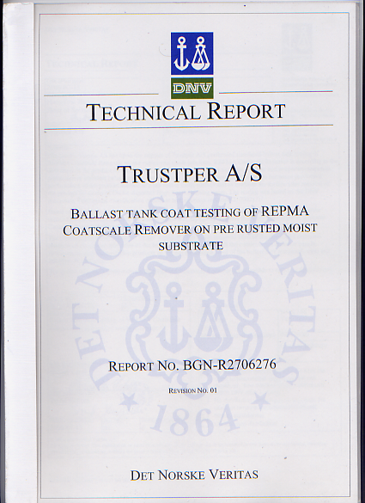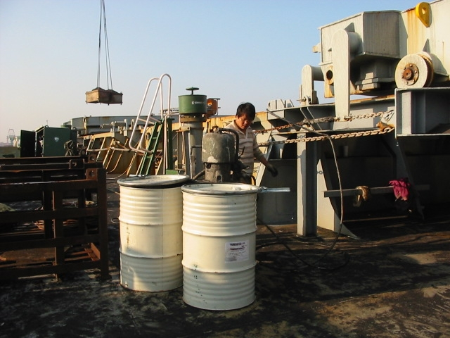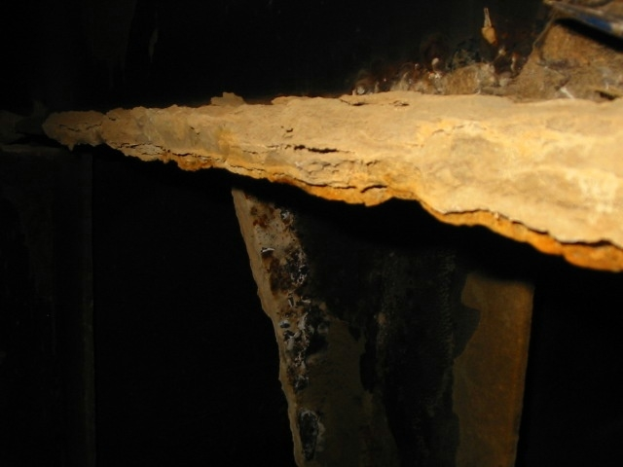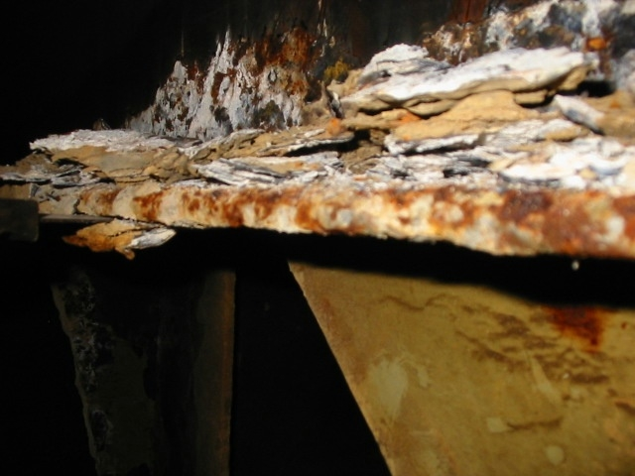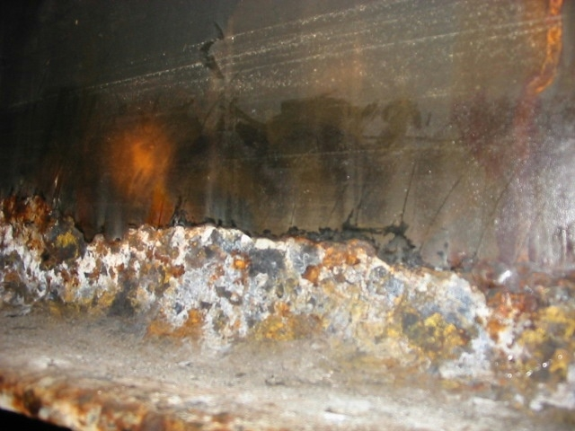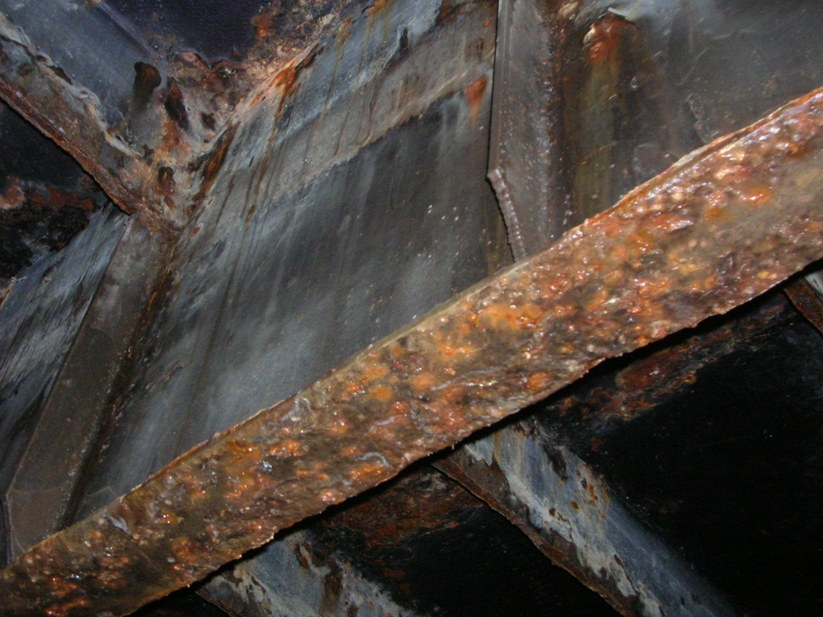

The “New Work Method” - Designated to fight onboard Corrosion in a new manner!

As Ship Owner or Ship Management Company you have most certainly been facing that one vessel or more in the fleet are exposed to corrosion challenges from time to time.
Every month during 2014 we will have an introduction page explaining the variety of our “Ballast Tank Maintenance Concept” thinking Green and indeed being cost efficient……

Photos above provide an example which intend to cover severe corrosive impact on a Stringer before “CSR” treatment were applied to surface by spray. The coating, “CSR” or “CoatscaleRemover” penetrates the substrate to multiple scale to layers resulting to loosen apart over time. Please then observe the loosen scale layers seen on the Stringer. When the loose scale has been removed you should also observe that the connecting bulkhead from Stringer still reflects applied “CSR” above exposed scale free surface.
After the initial Scale & Rust substrate removal, the unprotected exposed surface must therefore immediately be applied the 2nd time providing temporary protection up to 36 months or more, particularly optimal when “CSR II” has been applied….
The actual job for removal of rust and preservation of steel can easily be carried out by Vessels own crew during the voyage when ballast tanks are empty.

The Concept and its Maintenance Program for work procedure – progress and achievement expectations can as well be looked up at our website www.trustper.com
Particular problems related to mild steel-plates & internals within ballast tanks and void space is the main concern bringing challenges for how to cope for the most cost efficient maintenance available….

Subject Anti-Corrosion treatment Concept consist of following major 3 STEP’s

STEP I - “Rust & Scale Removal in Seawater Ballast Tanks”
STEP II - “Temporary Protection in compliance to Program “
STEP III - “Hard Paint Pre-prep allows Epoxy reapplication”

We are pleased to respond to any inquiry you may have, Concept details are also easily available at our website www.trustper.com / e-mail per@trustper.com
Reduced cost over time is a key success factor for repeated orders from Owners whom have learned how to play the new kind of the “preservation game”.

