AUGUST Page 2014
BALLAST TANK MAINTENANCE CONCEPT THINKING “GREEN”
P r o v i d e s T r e m e n d o u s S a v i n g P o t e n t i a l

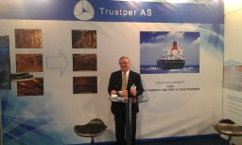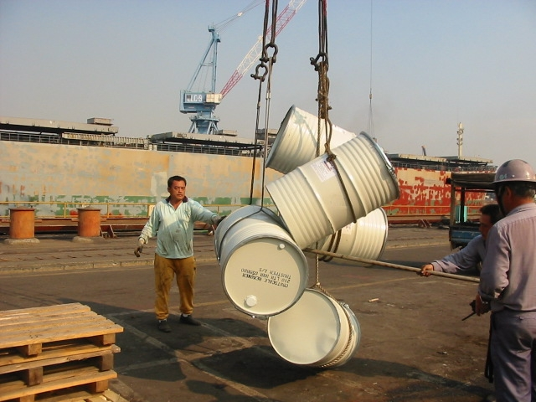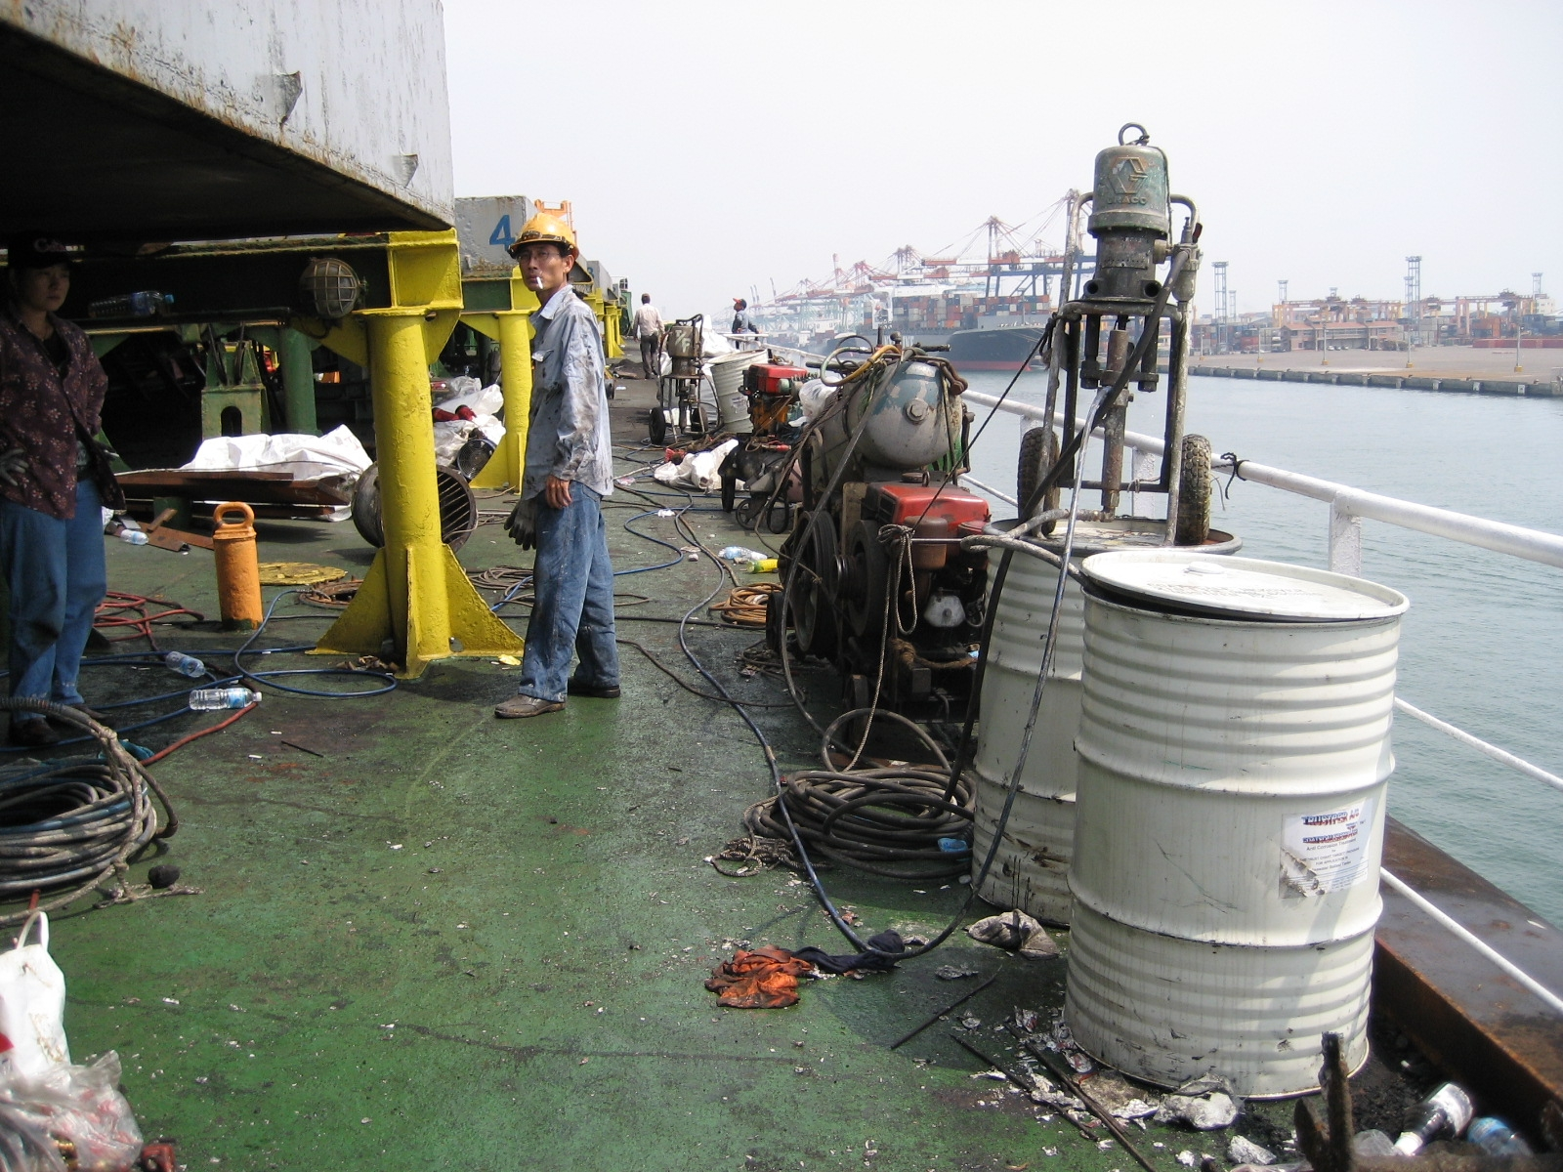
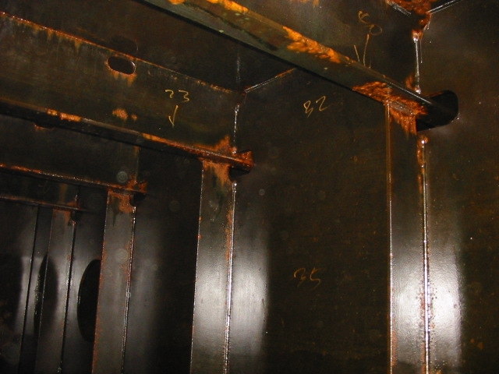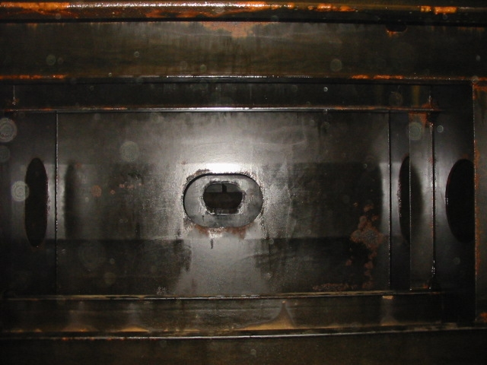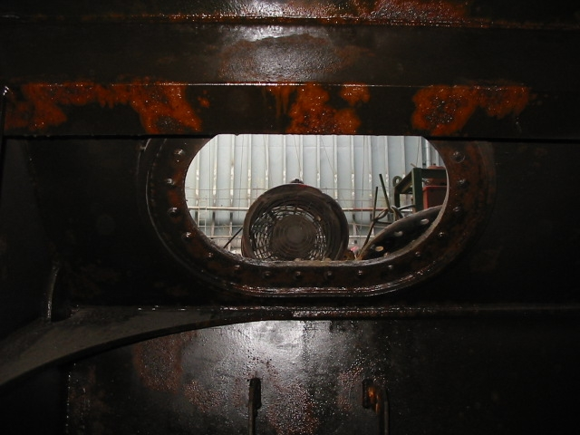

The “New Work Method” - Designated to fight onboard Corrosion in a new manner!

As Ship Owner or Ship Management Company you have most certainly been facing that one vessel or more in the fleet are exposed to corrosion challenges from time to time.
Every month during 2014 we will have an introduction page explaining the variety of our “Ballast Tank Maintenance Concept” thinking Green and indeed being cost efficient……
Photos above from no 1 upper left to 3 right provide examples on Exhibition participation and images seen from practical arrangement and how to apply equipment onboard a vessel. Image 4, 5 & 6 present appearances to surface in DB Tanks which have been treated with ref. to Concept recommendation. A faint shine is observed on entire tank surfaces reflecting a treated and clean surface after removal of impurities and scale layers. Photo no. 4, 5 & 6 reflects treated and protected old paint still well attached to surface because of NO under rust.
The actual job for removal of rust and preservation of steel can easily be carried out by Vessels own crew during the voyage when ballast tanks are empty. PS. Pay attention to the Curing Guide!!

The Concept and its Maintenance Program for work procedure – progress and achievement expectations can as well be looked up at our website www.trustper.com
Subject Anti-Corrosion treatment Concept consist of following major 3 STEP’s
STEP I - “Rust & Scale Removal in Seawater Ballast Tanks”
STEP II - “Temporary Protection in compliance to Program “
STEP III - “Hard Paint Pre-prep allows Epoxy reapplication.
We are pleased to respond to any inquiry you may have, Concept details are also easily available at our website www.trustper.com / e-mail per@trustper.com

